Lab Report No: 02

Name of the lab report: Basic Linux command.
Name: S.M.Hazrat Ali
ID: IT-17016

Objective: On linux operating system Terminal shell command line is preety much helpful.
Through this lab we know some basic commands of linux OS. Let’s what will the commands can do just followed. I take screen shot of my every activities.

Q.1. What is Linux command?
Ans:Command is an instruction given by a user operating the computer to do something like running a program or multi-programming .Commands are normally handling by typing in the command line & pressing ENTER which pass them to ‘shell’. The default shell on most Linux system is bash. On Linus the command line is known as ‘Terminal’. We can open it either by pressing “ ctrl+alt+t ” or find from application drawer.

Q.2. Write 15 commands of Linux operating system.
-----
- pwd command.
- cd command.
- uptime command.
- expr commands.
- free commands.
- history commands.
- id commands.
- Iw commands.
- lkillall commands.
- last commands.
- nproc commands.
- passwd commands.
- ping commands.
- pstree commands.
- top commands.
- uname commands.
- users commands.
- w commands.

Q.3. Describe the basic operation of Linux commands.
-----
pwd command :

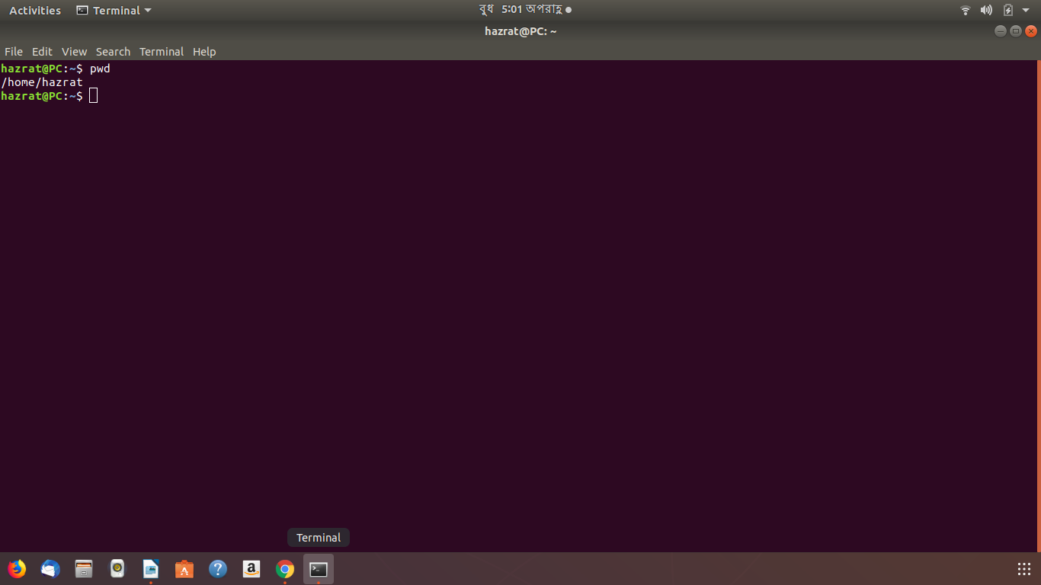
This command showss the location of my current working directory. It's important to know actually where i’m before going to a parent or sub directories.

cd command:

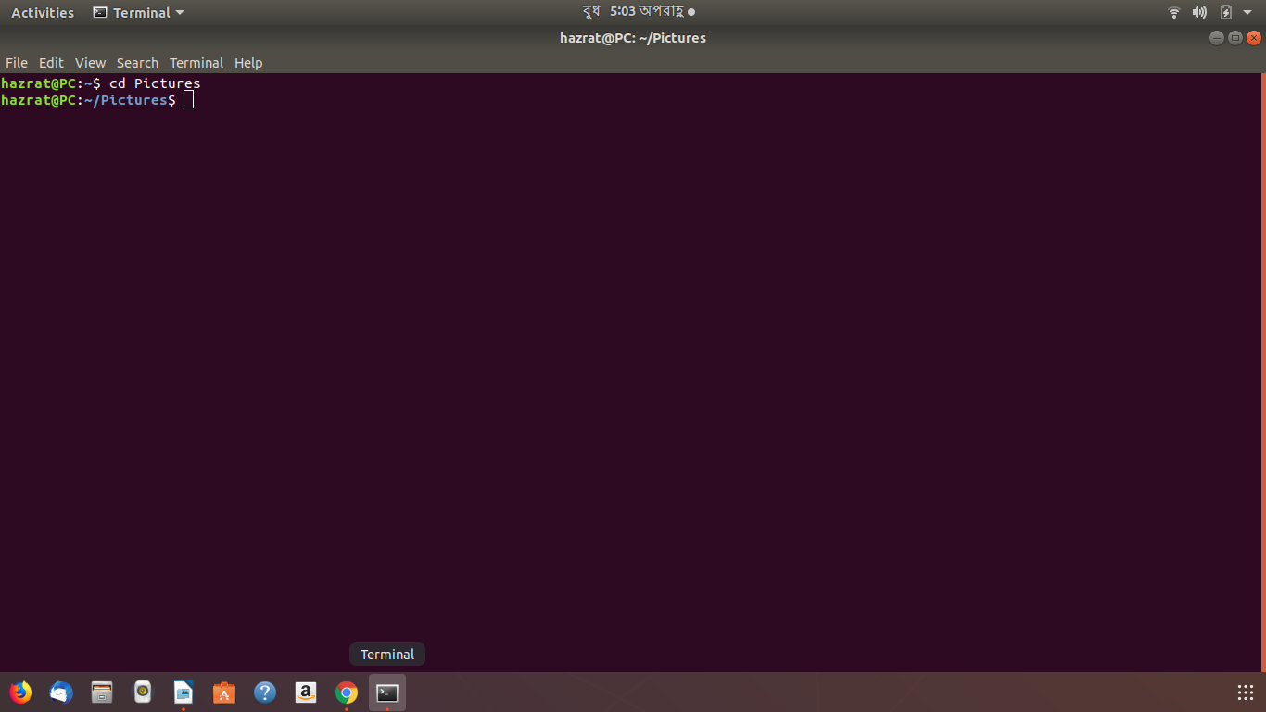
This command is used to go to a directory. For example, if you are in the home folder, and you want to go to the pictures folder, then you can type in“cd Pictures”. Remember, this command is case sensitive, and you have to type in the name of the folder exactly as it is.

uptime command:

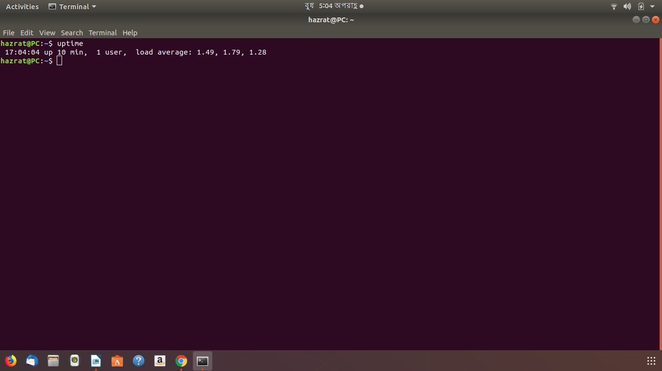

This command can be very interesting. Shows the time when we open our pc, how many times we use it , hour,seconds, minutes.

expr Command:
expr command is used to calculate an expression as shown below.
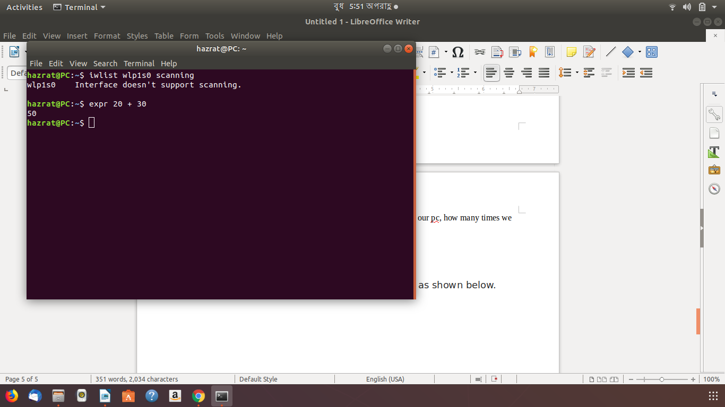

free Command:

free command shows the system memory usage (free, used, swapped, cached, etc.) in the system including swap space. Use the -h option to display output in human friendly format.
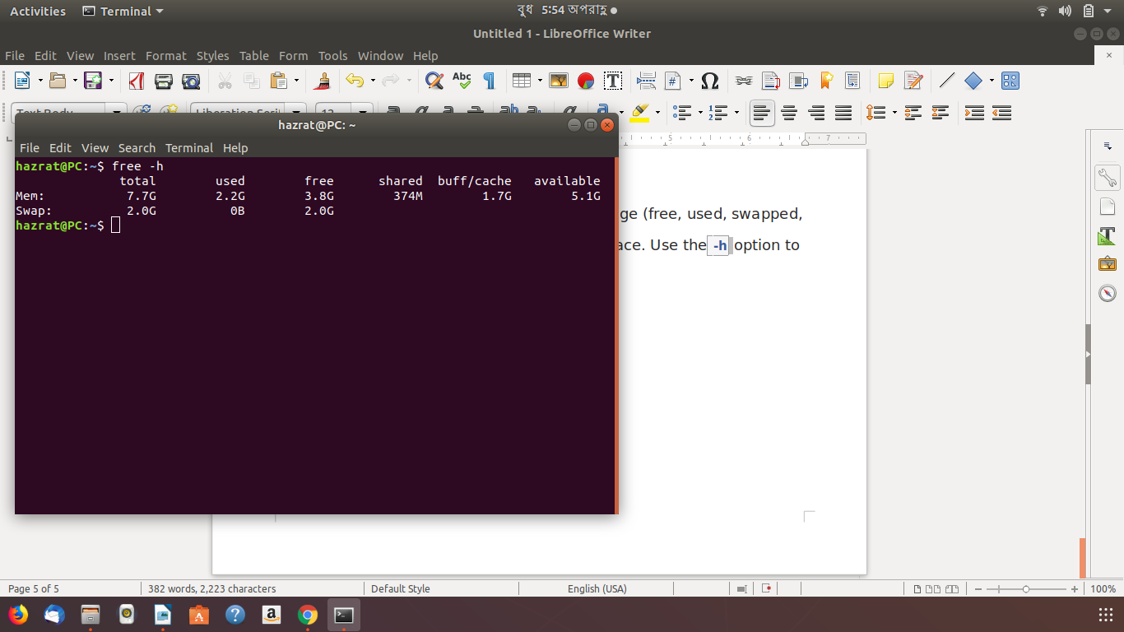
history Command:
history is used to show previously used commands or to get info about command executed by a user.
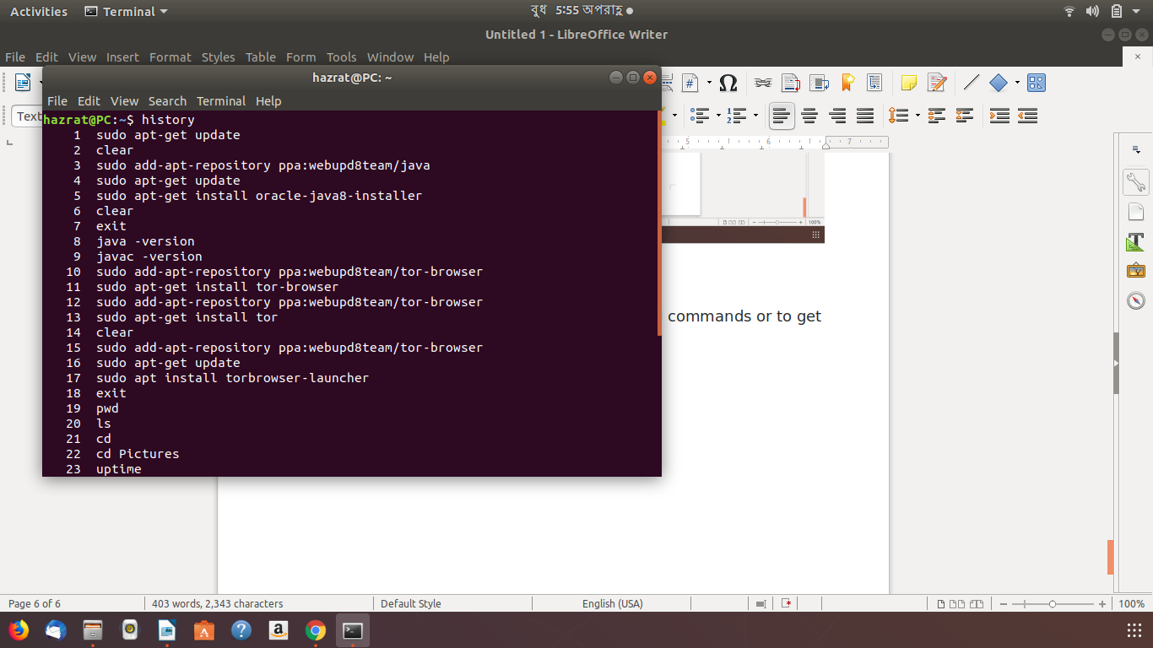

id Command
id command shows user and group information for the current user or specified username as shown below.
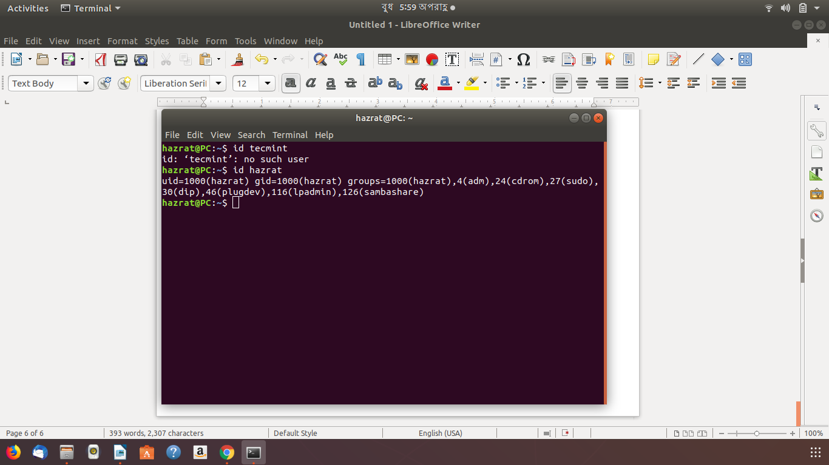

iw Command
iw command is used to manage wireless devices and their configuration.
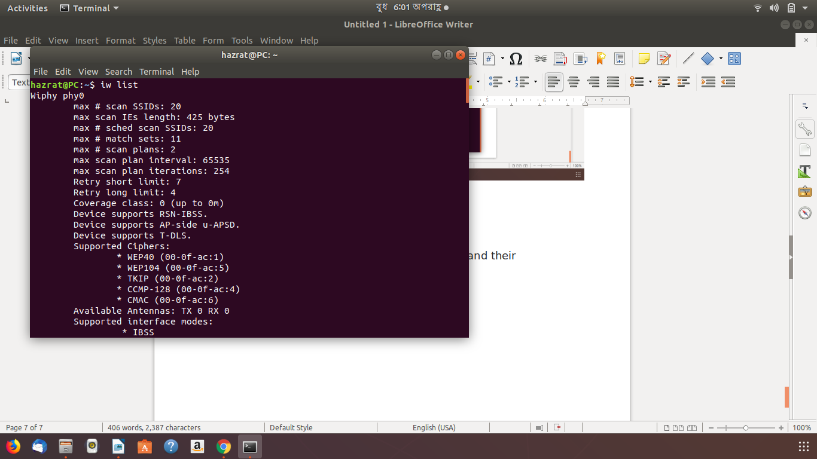

killall Command
killall command is used to kill a process by its name.
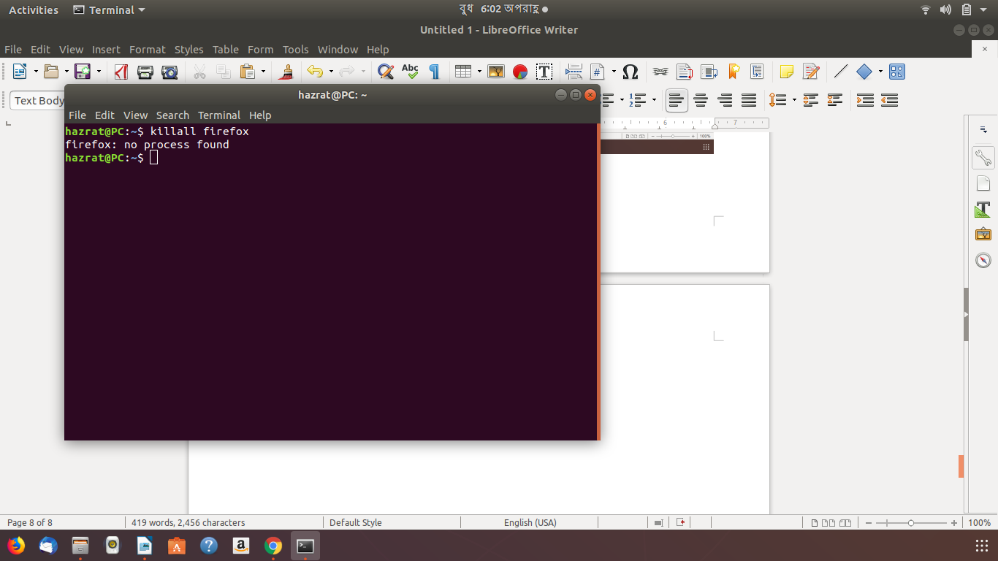

last Command
last command display a listing of last logged in users
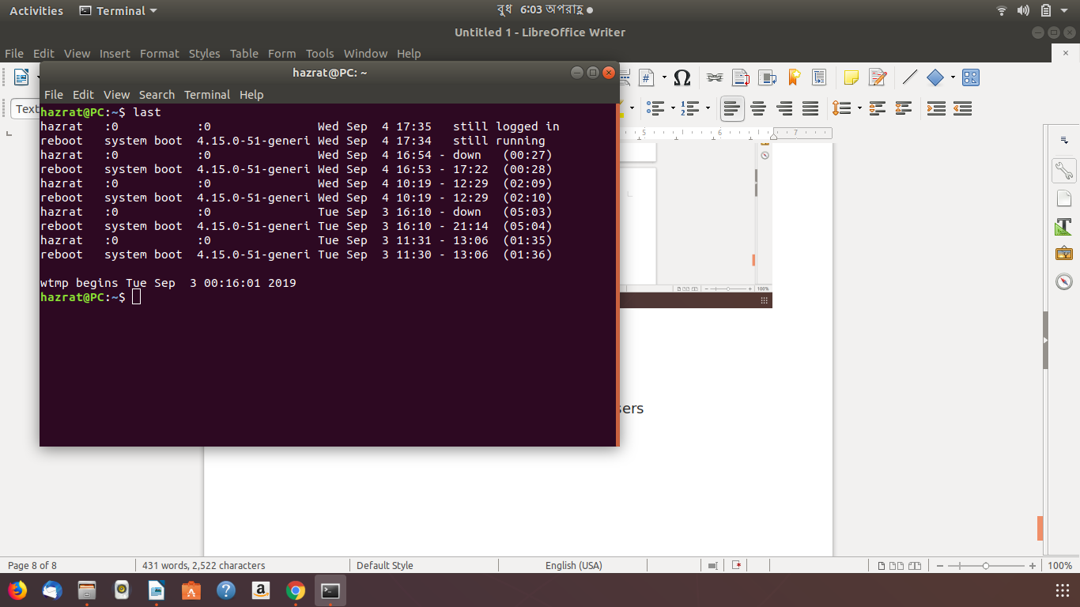

nproc Command
nproc command shows the number of processing units present to the current process. It’s output may be less than the number of online processors on a system.
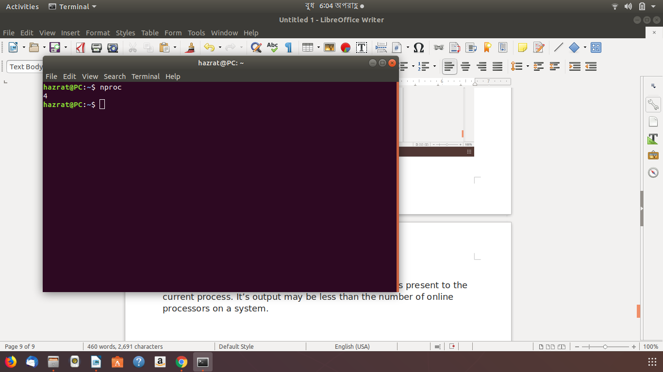

passwd Command
passwd command is used to create/update passwords for user accounts, it can also change the account or associated password validity period. Note that normal system users may only change the password of their own account, while root may modify the password for any account.
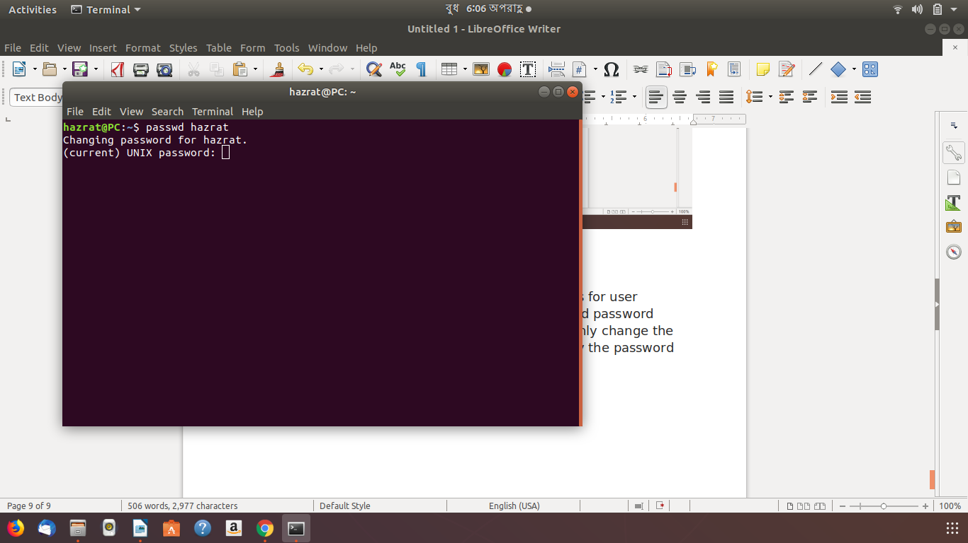

ping Command
ping command is used to determine connectivity between hosts on a network (or the Internet):
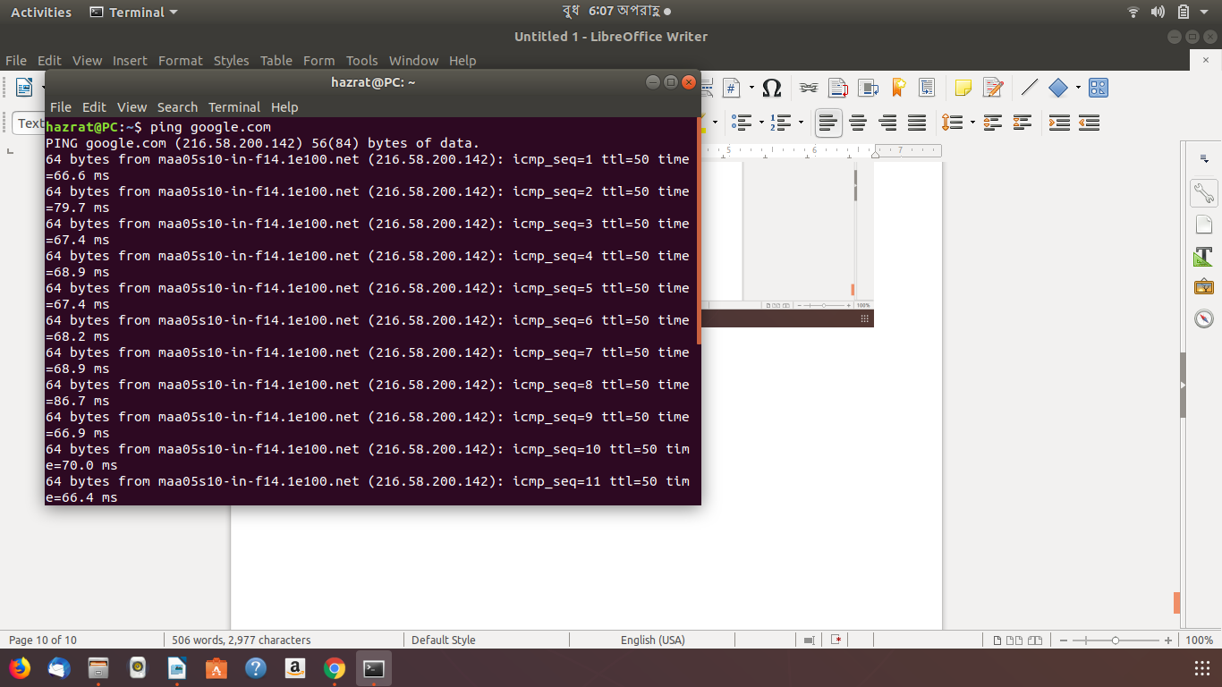

pstree Command
pstree displays running processes as a tree which is rooted at either PID or init if PID is omitted.
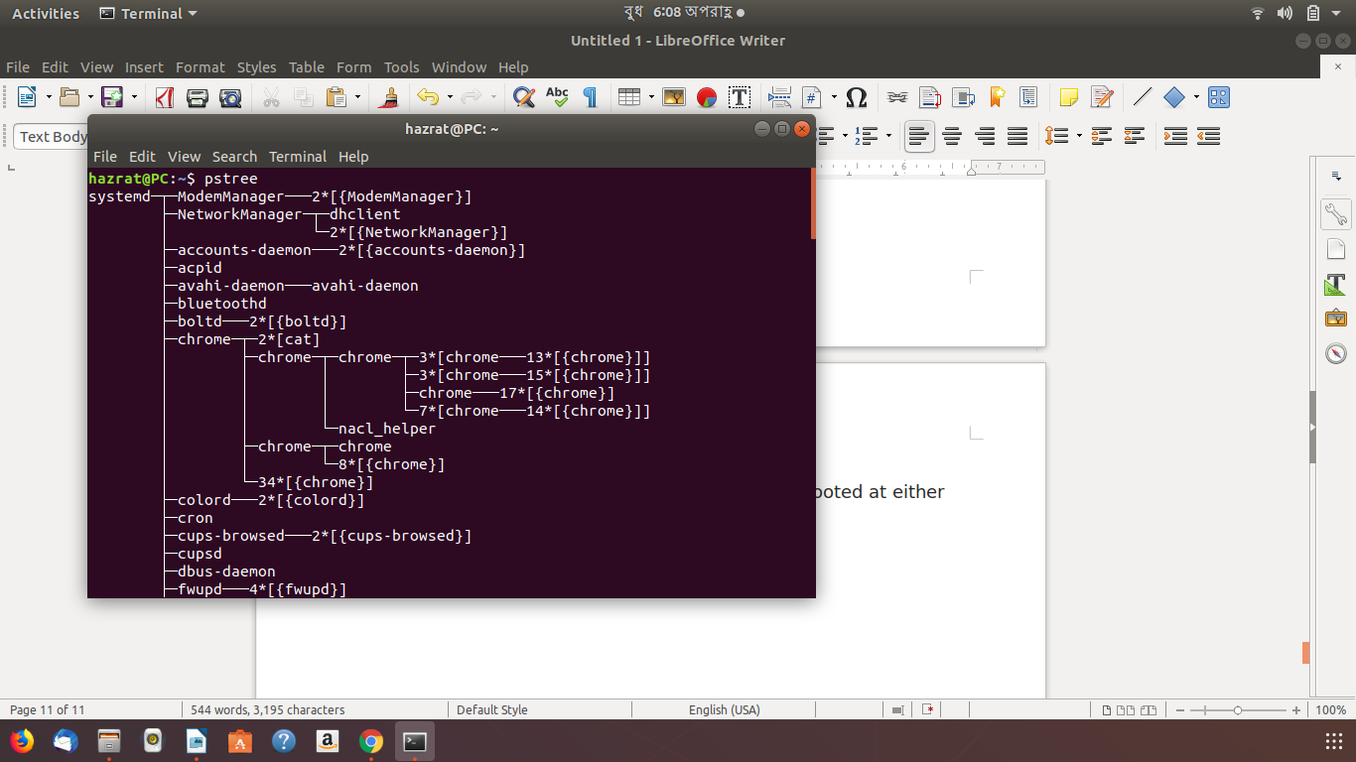

top Command
top program displays all processes on a Linux system in regards to memory and CPU usage and provides a dynamic real-time view of a running system.

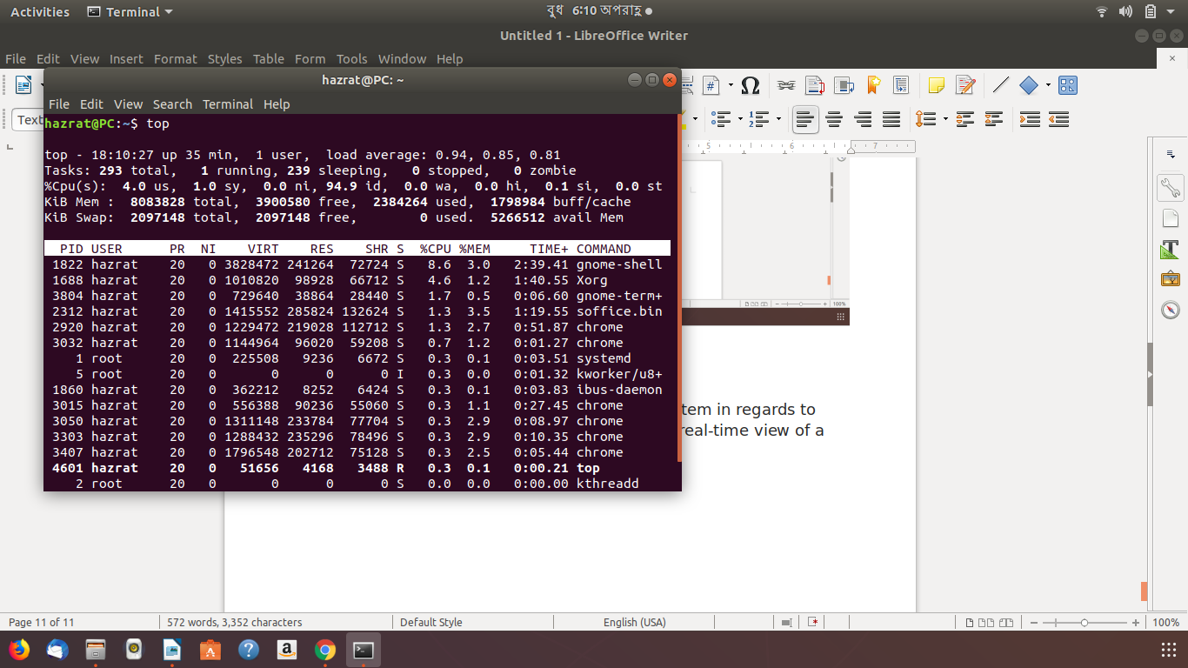

uname Command
uname command displays system information such as operating system, network node hostname kernel name, version and release etc.
Use the -a option to show all the system information:
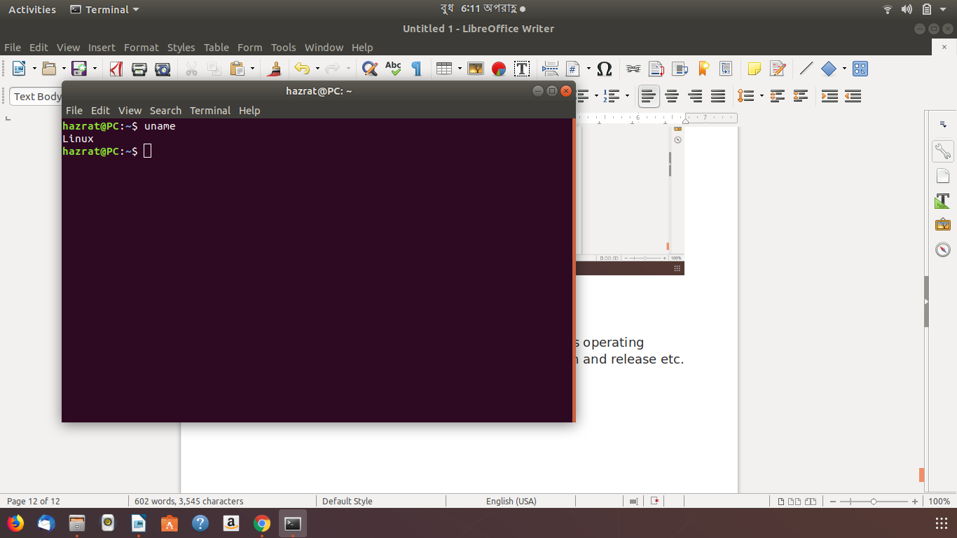

users Command
users command shows the user names of users currently logged in to the current host like this.
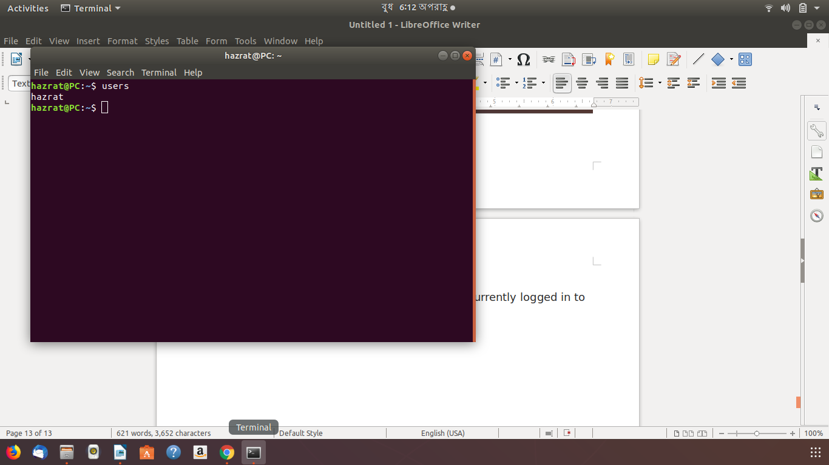

w Command
w command displays system uptime, load averages and information about the users currently on the machine, and what they are doing (their processes) like this.
